**Friday 26th September**

**Dear Parents and Carers**

We have reached the halfway point of the first half term of autumn and our school is buzzing with activity. I hope you enjoy a snapshot of some of the activities that have taken place in school this week. I have also included some information regarding our open morning – a full school really does help us in a whole manner of ways due to the increased levels of funding that we would receive. Please do share the date and times with anyone who may be interested!

Have a great weekend.

**Year 5 River Study at Severn Valley Country Park**

On Tuesday, our Year 5 pupils enjoyed a brilliant day out at Severn Valley Country Park, diving into hands-on geography in the great outdoors. The adventure began with a nature walk along the River Severn, where children identified key features along its course. They then collected data for fieldwork, measuring the river’s speed with impressive accuracy and enthusiasm.

After lunch, the group took part in pond dipping, discovering a variety of fascinating creatures living in the lower course of the river. The day ended with laughter and friendly competition during a lively game of Pooh Sticks.  
Staff on the trip were extremely impressed with the children’s geographical knowledge and curiosity—what a fantastic way to bring classroom learning to life! Thank you to Miss Taylor for leading this trip and to Mrs Hickman for organising in her role as Geography co-ordinator. Thank you also to Mrs Scotney, Mrs Hounsell and Mrs Dulson for accompanying the children.

**Open Morning and Afternoon – spread the word!**

Please ‘spread the word’ to anyone who is applying for a Reception school place for September 2026 – we can’t wait to show them our school!

Year 1 are having lots of fun exploring Yayoi Kusama's dots in art. We have explored creating dots of different sizes with different objects, and learning all about Kusama's artwork

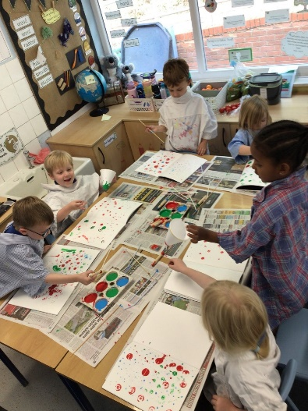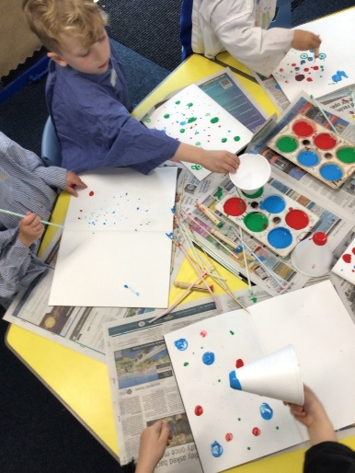

**Important dates for your diary – Autumn 1** (all dates for the academic year so far can be found on our school calendar [**St Joseph's Catholic Primary School Stourbridge - Calendar**](https://st-jo-st.dudley.sch.uk/Page/Calendar) **)**

**Tuesday 30th September 3:30pm** – Reception and KS1 parent phonics meeting

**Wednesday 1st October** – Black History Month begins

**Wednesday 1st October** – Year 6 Class Mass

**Thursday 2nd October** – National Poetry Day including poetry recital at 2:30pm (parents all welcome)

**Friday 3rd October** – Inset – school closed for pupils

**Monday 6th October** – Scholastic Book Fair

**Tuesday 7th October** – 9:05am - Year 2 stay and pray

**Wednesday 8th October** – 2:20pm Reception class prayer service

**Friday 10th October** – World Mental Health Day

**Saturday 11th October** – 5pm Welcome Mass for new Reception families at OLAS

**Monday 13th October –** Celebration Day for St Carlo (children in St Carlo to wear a yellow top)

**Tuesday 14th October –** 9:05am Year 4 stay and pray

**Wednesday 15th October -** 9:15-10:45am - Open morning for prospective parents September 2026

**Thursday 16th October** – Open afternoon for prospective parents September 2026

**Friday 17th October** – 2:30pm Year 3 class Mass (parents welcome to attend)

**Tuesday 21st October** – 9:05am Year 6 stay and pray

**Wednesday 22nd October** – 2:20pm – Key Stage 1 Mass (parents welcome to attend)

**Thursday 23rd October** – 4:00-6:30pm

**Friday 24th October** – Final day of the first half term of autumn

**Monday 3rd November** – school reopens for pupils

**Gifts from God**

The following children have received a certificate in today’s Gifts from God assembly. Well done children!

|  |  |  |
| --- | --- | --- |
| **Year group** | **Values and Virtues** | **Good Work** |
| **Reception** |  |  |
| **1** | **India** | **Dylan** |
| **2** | **Samuel** | **Nell** |
| **3** | **Lillia** | **James** |
| **4** | **Willow** | **Giorgia** |
| **5** | **Elienne** | **Ophelia** |
| **6** | **Anglina** | **Luke** |

**Weekend Mass times at Our Lady and All Saints Parish Church**

Have a great weekend

Mr Wilkes

Mr A. Wilkes

Interim Executive Principal